Food for Kidz
17th Annual Event - October 16, 2022
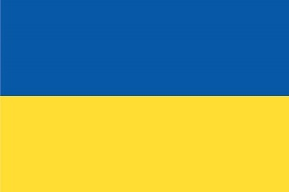
Pack Meals for Ukrainian Refugees

Dear ( )

Waunakee Food for Kidz is hosting our 17th annual packing event. We are excited about our new partnership with Orphan Grain Train, a non-profit based out of Westfield, WI. They provide aid to Ukraine war victims and will ship the meals packaged during Waunakee’s event to Ukrainian refugees in the war-torn area.

Meals will also be given to the Dane County Community Action Coalition (CAC) for distribution to local food pantries.

Last year, generous donations allowed us to package over 200,000 meals that were sent to the CAC, as well a shipping container filled with food and supplies to the Feed My Lambs Orphanage in Haiti. We thank you for your support, which fed and comforted a multitude of children and families in need.

Our 2022 goal is to raise $40,000, which will provide ingredients for 200,000 meals!

Your tax-deductible donation is sincerely appreciated:
- $25 provides 125 meals
- $100 provides 500 meals
- $250 provides 1,250 meals
- $500 provides 2,500 meals
- $1,000 provides 5,000 meals

Please send a check to Waunakee Food for Kidz in the enclosed self-addressed stamped envelope or donate online at waunakeefoodforkidz.org. The enclosed brochures outline donation levels and table sponsorship opportunities.

While raising money is our biggest challenge, we also need volunteers to help on October 16th to pack food during our three shifts. This is a wonderful family event that welcomes all ages to participate. Sign up online to register your spot as shifts fill up fast.
2022 FFK event
Waunakee High School Commons
301 Community Drive, Waunakee, WI
(Main westside entrance)
Shifts

10:00 AM – 12:00 PM
1:00 PM – 2:30 PM
3:00 PM – 4:30 PM

Questions? Please contact us at 608-332-3557 or Waunakeefoodforkidz@gmail.com.

Sincerely,

Waunakee Food for Kidz team

